European Research Council

ERC Consolidator Grant 2013
Research proposal
Part B1
(to be evaluated in Step 1)

“Encoded Chemical Libraries: Creating High-Throughput Cell-based Screening Platforms to Accelerate Drug Discovery”

ChemArrays

Proposal duration: 60 months

Principal Investigator (PI) : Juan Jose Diaz-Mochon

Host institution: University of Granada

Proposal summary

This project exploit the power of encoded chemical libraries as a tool for studying phenotypic modifications and cellular differentiation induced by small-molecule for both adherent and suspension cell lines. For the very first time this platform will allow small-molecules to be uptaken by cells in order to induce phenotype changes while still being able to track down each individual molecule cellular impact up to a single cell level. This will be possible by using linkers between small-molecules and their barcode tags which can be broken without the system losing its encoding power. Two different approaches will be used (i) for adherent cells: a single 2D platform will be converted into a hybrid DNA-polymer-small molecule microarray mixtures where small molecules will be organised spatially in virtue of DNA-PNA hybridization properties. Macromolecular hydrogels will act as mini-wells ,allowing cell based screenings using over 10,000 different compounds in a single experiment. And (ii) for suspension cells: ChemArrays introduce a new concept called ‘one-bead-one-compound & one-cell-one-bead’ (OBOC & OCOB) which will be able to identify chemicals responsible of inducing phenotypic changes into single cells. Therefore this project will deliver a highly innovative technology which will help to find new chemicals and chemical combinations as drugs and also as drivers of cell differentiation. Inducing cellular differentiation by synthetic entities is key to achieve safe and robust cellular therapy products and as this nascent field do not have enough lead compounds to build on them, ChemArrays could be of great for it. ChemArrays project is the bridge which has been missing for 20 years in the field of encoded chemical libraries making possible to use those libraries within complex biological models taking into account dynamic biological processes rather than isolated systems.

Section a: Extended Synopsis of the scientific proposal (max. 5 pages)

Description of the proposed work in the context of the state of the art of the field:
Encoded chemical libraries have been validated as an innovative way to greatly accelerate the discovery of interactions between small-molecules and biomolecules of importance such as enzymes and nucleic acids, thus becoming a technology which has attracted increasing interest from biotech and pharmaceutical companies.[1-2] These encoded strategies have been presented as a solution to screen large combinatorial libraries against biomolecules in a meaningful manner and offering a second chance to combinatorial approaches. Once, combinatorial chemistry was hailed as the future for drug discovery due to their ability of generating large number of compounds in relatively short period of time, however those great hopes were never met as they could not generate many meaningful biological data. The difficulty to screen large libraries of compounds within biological systems could not be initially overcome but encoding approaches are changing this perception. For the encoding task, DNA and Peptide Nucleic Acids (PNA) have already being used as barcode tags for a variety of applications, most notably the elegant work of David Liu in Harvard [3] and Nicolas Winssinger [4] in Strasbourg and also by myself together with Mark Bradley in Edinburgh [5]. During the past 8 years dozens of large DNA encoded small-molecules libraries have been synthesised by big institutions such as Standford, ETH Zurich and Harvard and also big pharma companies such as GSK using split-and-mix approaches, which allow synthesising a number of compounds which increase exponentially with the number of chemical steps and therefore reducing massively time and materials required. [1, 6-8] However to date it has not been possible to test the effects of encoded small molecules on cellular phenotype in a microarray format. The latest innovation in this field has presented the use of PNA encoded peptide libraries with cellular systems such lymphocytes and adherent cell lines to find peptides as selective cellular penetrating peptides [9] and integrin ligands [10], an innovation of which I have been a key part of it.
While those latest results show the feasibility of using these libraries with more complex systems it does still not resolve the issue of how release encoded small-molecules within cells to induce phenotypic changes and then unequivocally identified which small-molecules are responsible of those changes. In order to truly be considered a proper platform based on large library of compounds for accelerating drug discovery and also finding chemicals which induce cellular differentiation the previous issue has to be resolved for both suspension and adherent lines (e.g. stem cells, primary cells, suspension, cancer stem cells, circulating tumoral). This proposal presents key innovative steps to allow the use of large encoded libraries as chemical tools to create High-Throughput Cell-based Phenotypic Screening Platforms.
A key issue to be resolved is how to cleave small-molecule compounds from their tags and still be able to track down that small-molecule after causing a phenotypic change in the cell. ChemArrays offer two different approaches depending on cell type.
- 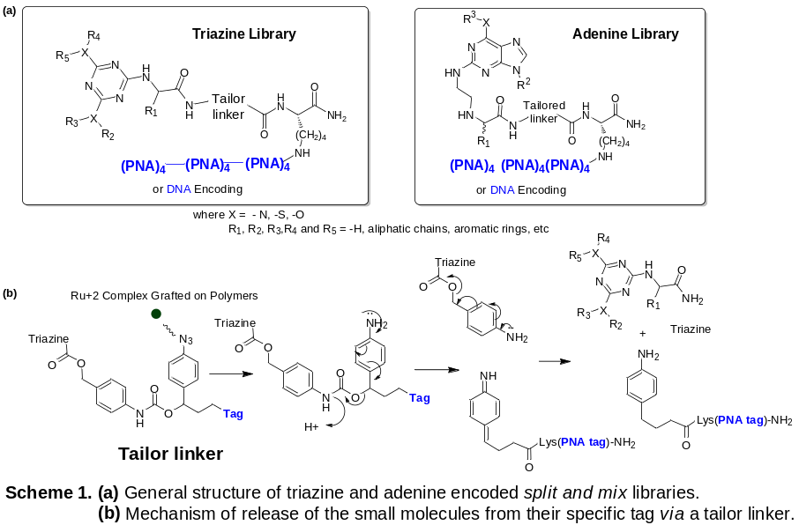Adherent cells. In this part, split and mix libraries having both PNA and DNA barcode tags will be synthesised on solid support, following established protocols. [1, 10] Two libraries based on triazine and adenine scaffolds will be initially prepared (see Scheme 1). The key issue will be resolved by using (i) polymeric hydrogels and (ii) tailored cleavable linkers between the small-molecules and their PNA or DNA tags. The polymers in this proposal will act not just as biocompatible supports to favoured cellular attachment but also as both catalyst to allow cleavage of the tailored linkers and micro-wells to maintain small-molecules in defined places. ChemArrays propose a cleavable immolative linker which following UV activation of Ruthenium complexes would give rise to a Staudinger reaction and cleave the small-molecules from their tags.[11] In this way, hydrogels will be ‘decorated’ with ruthenium complexes.
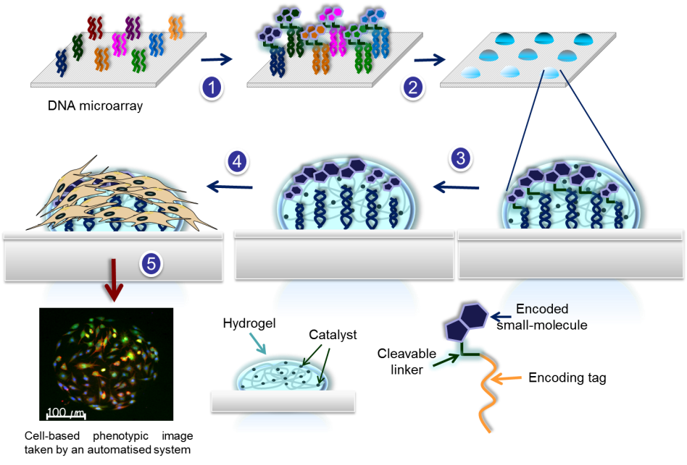
This innovation will allow assessing ‘free’ small-molecule actions and not as big conjugated with their tags, DNA or PNA, which might distorsionated the real biological effect of small-molecules. These arrays will be thus base on cell-based polymer microarrays, a technology which has been exploited mainly by Prof. Langer from MIT [12] and Prof. Bradley with myself in Edinburgh [13-14] and given rise to a broad variety of applications from finding anti-bacterial materials [12] to materials which induce phagocytosis [15], hepatic cell growing and thermo-responsible hydrogels for stem cell manipulation [16] to name just a few. ChemArrays will use the features of DNA/PNA to decode the libraries. Encoded small-molecules will be organised into a defined xy array format via perfect matching between PNA or DNA barcode tags and their complementary DNA oligomers printed onto defined 2D xy coordinates [17]. Therefore, each small-molecule will then be addressed to a specific and defined position and will be displayed in fixed positions of the surface (step 1). Then, hydrogels capable to favour cellular adhesion and grafted with metal catalyst to cleave the linker between tags and small-molecules will be deposited onto the array (step 2). Linkers will be cleaved ( step 3) and cells will be seeded and will grow on top (step 4). Stimuli-responsible hydrogels will be used in order to control the delivery of chemical entities embed in them once cells are adhered, acting as retarding delivery system. [16-18] Following immunostaining, the use of imaging systems such as high resolution scanners based on fluorescence microscopy will be used ( step 5).[13]
Figure 1. Adherent cells ChemArrays (High-Throughput Cell-based Screening Platforms for adherent cells). Steps: 1) Immobilisation of small molecules encoded library to the DNA microarray , 2) Hydrogels deposition onto the array, 3) Linker cleavage (4) cell growing, (5) Immunostaining and Imaging – Phenotypic analysis.

These systems have flexible resolutions (up to 0.2 μm) and able to use up to eight different fluorophore channels together with robotic to allow automation, essential to scan high-density arrays. Small-molecule concentrations have to be thought as local concentrations in spots so that they will be high enough to allow cells to uptake them. This approach will have the ability of creating different small-molecule formulations per position just by simply mixing DNA oligos at different positions (see step 1 in Figure 1). The challenge of finding grafted polymers with the requirements mentioned above will be greatly minimised by applying a methodology developed by myself to fabricate hydrogel microarrays using a robotic inkjet printer to perform in situ nanolitre-scale.[18] This approach will allow to use this technology to any type of cell line as specific materials could be designed ad hoc for each cellular type. DNA microarrays will be purchased by manufacturers such as Agilent or OGT which offer custom DNA microarrays using their proprietary technology to synthesise DNA oligonucleotide directly on the array at a competitive price. Therefore, this application does not present big technological challenges which could make it unfeasible.

The innovative delivery of this part will thus be hybrid DNA-small-molecules-polymer microarrays as high-throughput platforms for cell-based assays. This platform will become a very useful tool to develop patient-based cancer drugs helping to asses rapidly drug efficacy using primary tumor cell lines. Its unique features, automation, multiplexing and low amount of cells required to identify small molecules that target those cell lines, especially hard to drug cell lines, such as cancer stem cells could mean a critical shift in the field of personalised medicine.

An alternative to ChemArrays could be to use high-throughput small-molecule screen by spotting on a defined array format individual compounds.[19] To achieve that, compound libraries (up to 10,000 members libraries) would have to be synthesised in a parallel fashion while ChemArrays will carry out the synthesis of these libraries using split and mix techniques, meaning a dramatic reduction of time and material. Also, spotting small-molecules onto 2D surfaces would have issues regarding cross-contamination, when high-density arrays will have to be produced, due to the lack of any strong interaction between surfaces and molecules. Other alternatives such as pre-mixed compounds and polymers before spotting would be not achieved the desire high-throughput results, one library would have to be used with just one polymer and therefore to test just a single cell line.

This platform will be initially applied to study phenotypic changes in cancer stem cells and differentiation processes in pluripotent cell cultures (i.e., embryonic carcinoma) that can be obtained from commercial sources. Dr. Juan Antonio Marchal from the University of Granada will support the cancer stem cells application by using cancer stem cells from colon, breast and melanoma and looking at both plurypotency markers such as Oct-4, Nanog and Sox 9 and specific cancer stem cell markers such as ALDH1, CD44 and CD133. The applications regarding the generation of iPS cells from adult somatic cells will be supported by Dr. Jose Luis Perez Garcia from GENyO. A few molecules have already been identified with the ability to either improve the process of reprogrammation or replace one or two of the genes deemed necessary for reprogramming.[20] We will screen our enconded libraries looking for small molecules that can replace some of these reprogramming transcription factors.
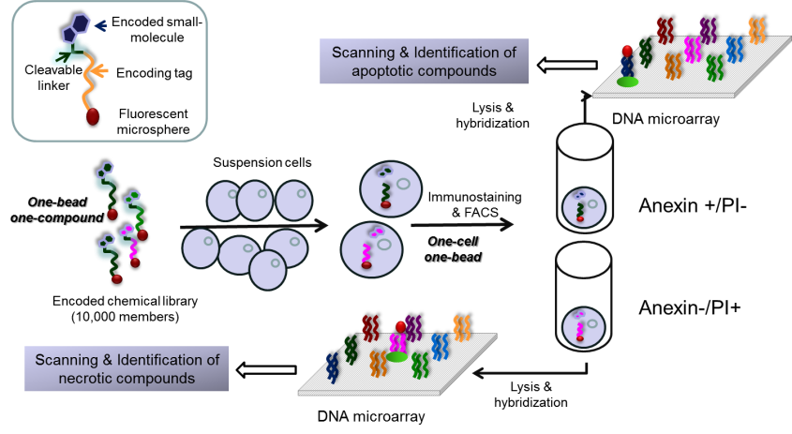
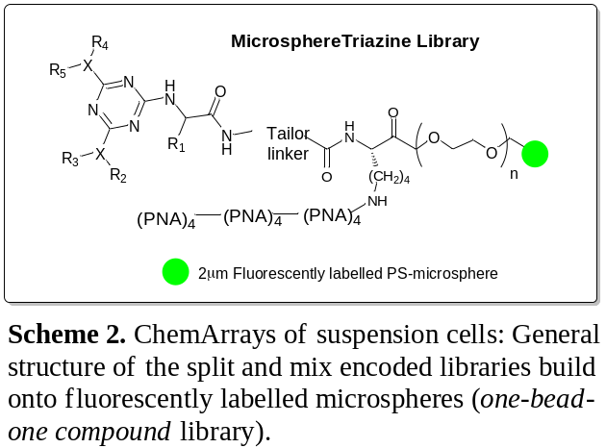(ii) For suspension cells. In this case, a different and more challengeable approach has to be followed. A perfect assay could be named as one-bead-one-compound & one-cell-one-bead (OBOC & OCOB) as it would need to be able to have just one encoded small-molecule per cell and be released intracellularly Then, following immunostaining, cells could be sorted by fluorescence-acting cell sorting (FACS) based on phenotypic changes and, at that stage, still be able to track down which small-molecules are responsible of certain phenotypic changes (see Figure 2). To meet those needs, ChemArrays proposes to encode libraries using, in this case, just PNA instead of DNA to avoid cellular nucleolytic activity, and to be built on microspheres to create solid-supported libraries. If compare with approach (i) libraries will be kept supported on microspheres to be used with cell cultures. ChemArrays will use polystyrene microspheres (0.1μm to 2μm) developed by Dr. Sanchez-Martin (who works at the Universidad of Granada and also is ascribed to GENyO Research Centre, as my myself, and who will support this project) and Prof. Bradley which have been proven to be very efficient and non-toxic intracellular carrier systems which allow also carrying out multi-step solid phase organic chemistry reaction.[21] These carrier systems are uptaken by cells (beadfection) in a time and size depending manner, so it could be controlled to have the biggest population of cells with just one microsphere. Unpublished results suggest that 2µm microspheres will be the size of choice as with that size achieving the goal one-cell-on-bead is quite likely. Using FACS gating, that population could then be clearly identified thanks to use fluorescent microspheres with a fluorophore different to the immunostainning reagents. These assays will be performed at GENyO which is equipped with last generation FACS facilities. In the chemical part, a standard split and mix approach following solid-phase methodologies, will guarantee that one microsphere will have one compound (see Scheme 2).
Figure 2. Suspension cells - ChemArrays (High-Throughput Cell-based Screening Platforms for suspension cells). Steps: 1) Incubation of suspension cells with encoded chemical library conjugated to fluorescently labelled microspheres (carrier systems), 2) Immunostaining and FACS (one-cell-one-bead strategy) 3) lysis of sorted populations of cells and hybridization to DNA microarray (or PCR amplification) – Deconvolution step.

One-bead-one-compound & one-cell- One-bead-one-compound & one-cell-one-bead is essential to make sure that phenotypic changes are caused by a single chemical entity and not by random events which could not be tracked down. Once, sorted out cell populations with certain phenotypic profiles, cell lysate containing microspheres linked to their PNA tags will be decoded by either DNA microarray or PCR.[10, 22] A key consideration for this type of assays is that it will measure the impact of small-molecules just in cells which have uptaken microspheres but not in their off-spring cells. This approach will thus convert this cell-based assay into a large single-cell assays where hundreds of different small molecules are assayed against millions of different cells in a single well.
This platform will be used to study phenotype changes in human immortalised myelogenous leukemia cell line K562 in collaboration with Prof. Ignacio Molina ´s research team from the University of Granada.

Ground-breaking nature of the research project :
This project will deliver a highly innovative technology which will help to find new chemicals and chemical combinations as drugs and also as driver of cell differentiation and therefore direct applicable to cell therapy at a speed not seen before. Inducing cellular diferentiation by synthetic entities is key to achieve safe and robust cellular therapy products and this nascent field do not have of enough lead compounds to build on them. ChemArrays could thus be of great help to find new chemical entities.Apart from that, ChemArrays will become a useful tool to develop patient-based cancer drugs helping to asses rapidly drug efficacy using primary tumoral cell lines. Its unique features, automation, multiplexing and low amount of cells required to identify small molecules that target those cell lines, especially hard to drug cell lines, such as cancer stem cells could mean a critical shift in the field of personalised medicine. Finally, this technology will also be valuable for chemical genetic screens. Chemical genetics involves testing thousands of small molecules for their effects on a cellular or organismal phenotype; subsequently, the proteins targeted by these phenotype-modifying compounds are identified.
The development of such an exciting and innovative technology may provide opportunities to engage with European and multinational companies specialised in drug discovery and as well as potentially providing new market opportunities to develop new platforms to support the exploitation of the technology.
The opportunities in the medium and long term are:
• Large and financially active market which need advances in technologies to give an answer to the personalised medicine era.
• Potential for considerable licensing deals with pharmaceutical and biotechnology companies through direct agreement between those companies and either the University Knowledge Transfer Office or a spin-off created from the intellectual property generated.
• Potential to be useful as background IP to areas such as drug discovery, cell-based therapies, chemical biology, biotechnology and nanotechnology.
• Students and postdoctoral researches will gain an unique set of cross boundary skills which will make them to become strong candidates for competitive scholar and fellowships and also very attractive in the highly competitive biotechnology job market.
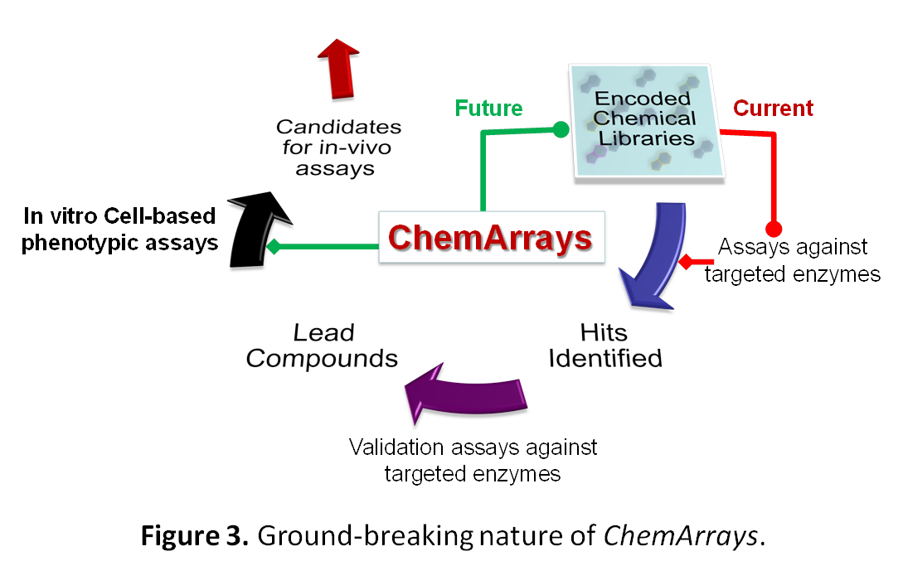
In the short term the project will also deliver development and innovation in the different discipline involved in this project. For instance the material chemistry area will benefit from the new findings and the new metal-decorated hydrogels created during the project which could then be used for novel applications in the field of regenerative medicine. In the case of the nanotechnology field the development of PNA- microspheres will have a direct application in the diagnostic area. Finally, it is quite likely that this platform will also be applied to study PNA and DNA mimics as therapeutic agents themselves. All these paralell applications de-risk the project as a whole.

ChemArray project will be then the bridge which has been missing for 20 years in the field of encoded chemical libraries making possible to use those libraries with complex biological models which take into account dynamic biological processes rather than isolated systems as the current ones. As summary, it can be said that ChemArrays will offer encode chemical libraries a shortcut to get to in-vivo stages, accelerating thus the always very challenging drug development pathway and offering an alternative to animal testing (see Figure 3).

Overall aims and objectives of the research programme:

(a) Development of a HTS methodology to analyse arrays of metal-grafted hydrogels for cellular attachment while allowing controlled release of small molecules.
(b) Synthesis of split and mix DNA and PNA-encoded libraries of small-molecules using solid phase chemistry.
(c) Spatial organization of the libraries in a 2D format using DNA microarrays, based on PNA-DNA hybridization properties
(d) Production of DNA-small molecules-polymer hybrid arrays.. This will allow cleaving of small-molecules from barcode tags while embed in the polymer spots. Polymer spots will act as mini-wells where cells will be adhered and small-molecules released.
(e) Use of hybrid arrays to carry out cell-based assays to study phenotype changes in cancer cell lines, including cancer stem cells, and differentiation process in pluripotent cell cultures (i.e., embryonic carcinoma) that can be obtained from commercial sources.
(f) Synthesis of a PNA-encoded library of small-molecules on polystyrene-microspheres.
(g) Use of the PS-microsphere supported PNA-encoded library to study phenotype changes in human immortalised myelogenous leukemia cell line K562 assisted by fluorescence-activated cell sorting (FACS)

References :
- Clark, M.A. et al, Nat. Chem. Biol., 2009, 5, 647-654.
- Kleiner, R.E., Dumelin, C.E., Liu, D. R., Chem. Soc. Rev., 2011, 40, 5707-5717.
- Chen, Y., Kamlet, A. S., Steinman, J.B., Liu, D. R., Nature Chemistry, 2011, 3, 146-153.
- Chouikhi, D., Ciobanu, M., Zambaldo, C., Duplan, V., Barluenga, S., Winssinger, N., Chem. Eur. J., 2012, 18 (40), 12698-12704.
- Pouchain, D., Díaz-Mochón, J.J., Bialy, L., Bradley, M., ACS Chem. Biol., 2007, 2 (12), 810-818.
- Buller, F. et al, ACS Chem. Biol., 2011, 6, 336-344.
- Kleiner, R.A., Dumelin, C.E., Tiu, G.C., Sakurai, K., Liu, D.R., J. Am. Chem. Soc., 2010, 132, 11779-11791.
- Heng, H. et al, J. Med.Chem., 2012, 55, 7061-7079.
- Svensen, N.; Diaz-Mochon, J. J.; Dhaliwal, K.; Planonth, S.; Dewar, M.; Armstrong, J.D.; Bradley, M. , Angew. Chem. Int. Ed., 2011, 50(27), 6133-6136.
- Svensen, N.; Diaz-Mochon, J. J.; Bradley, M., Chem. Biol., 2011, 18, 1284-1289.
- Röthlingshöfer, M., Gorska, K., Winssinger, N., Org. Lett., 2012, 14 (2), 482-485.
- Hook, A.L. et al., Nat. Biotech., 2012, 30 (9), 868-875.
- Pernagallo, S.; Diaz-Mochon, J. J.; Bradley, M., Lab on a Chip, 2009, 9, 397-403.
- Pernagallo, S. et al., Advanced Healthcare Materials, 2012, 1(5), 646-656.
- Mant,A., Tourniaire, G., Diaz-Mochon, J.J., Elliott, T.J., Williams, A.P., Bradley, M., Biomaterials, 2006, 27(30), 5299-5306.
- Zhang, R., et al., Nat. Comm., 2013, 4(30), 1335 (doi:10.1038/ncomms2341).
- Diaz-Mochon, J.J.; Bialy, L., Bradley, M., Chem. Comm., 2006, 38, 3984-3986.
- Zhang, R., Liberski, A., Khan, F., Diaz-Mochon, J.J.; Bradley, M., Chemical Communications, 2008, 11, 1317-1319.
- Bailey, S.N., Sabatini, D.M., Stockwell, B.R. , PNAS, 2004, 101, 16144-16149.
- Desponts C, Ding S., Methods Mol. Biol., 2010, 636, 207-218.
- (a) Unciti-Broceta, A.; Díaz-Mochón, J. J.; Sánchez-Martín, R. M.* and Bradley, M.* Accounts of Chemical Research, 2012, 45(7), 1140-1152. (b) Yusop, M.; Unciti-Broceta, A.; Johansson, E. M.V.; Sánchez-Martín, R. M.; Bradley. M., Nature Chem., 2011, 3, 239-243.
- Svensen, N.; Diaz-Mochon, J. J.; Bradley, M., PLoS ONE, 2011, 6(9), e24906

Section b: Curriculum vitae (max. 2 pages)

ACADEMIC ACHIEVEMENTS:

UNIVERSITY EDUCATION
1997-2001 PhD in Pharmacy (Medicinal Chemistry) Deparment of Medicinal and Organic Chemistry, University of Granada, Spain. Mark Obtained: Cum Laude.
1991-1996 Degree in Pharmacy. Mark Obtained: 3.1 (Scale 1-4) University of Granada, Spain. Equivalent to 1st Class Honours Degree.

RESEARCH EXPERIENCE
• 1995-1996: Erasmus student at the Dipartimento di Chimica e Tecnologia del Farmaco (Department of Chemistry and Drug Technology), Università degli Studi di Perugia. Perugia, Italy, under the supervision of Prof. Pellichari.
• 1997- 2001: PhD student in the Department of Medicinal and Organic Chemistry, Faculty of Pharmacy,
University of Granada, under the direction of Prof. Espinosa Ubeda, Head of Deparment. Regional Government fellowship.
• 2000: visitor research student at the Dipartimento di Scienza Farmaceutica, Università degli Studi di Ferrara. Ferrara, Italy, under the supervision of Prof. Baraldi(3 months).
• June 2001- January 2002: postdoctoral fellow in the Department of Medicinal and Organic Chemistry, Faculty of Pharmacy, University of Granada, under the direction of Prof. Espinosa Ubeda, head of deparment.
• Februrary 2002- June 2003: Post-doctoral research visitor at the School of Chemistry, University of Southampton, under the supervision of Prof. Mark Bradley.
• July 2003- January 2005: Post-doctoral research assistant at the School of Chemistry, University of Southampton, under the supervision of Prof. Mark Bradley.
• February 2005-June 2008: Post-doctoral research assistant (PDRA) at the Chemical Biology section, School of Chemistry, University of Edinburgh, under the supervision of Prof. Mark Bradley.
• July 2008-October 2010: Researcher Fellow of the Chemical Biology section, School of Chemistry, Mentor: Prof. Mark Bradley.
• April 2010-May 2011: Chief Scientific Officer, DESTINA Genomics Ltd. Spin-off company of the University of Edinburgh.
• June 2011-to-date: Member of Scientific Advisory Board, DESTINA Genomics Ltd.
• June 2011-May 2016: Ramón y Cajal Researcher, Department of Medicinal and Organic Chemistry, Faculty of Pharmacy, University of Granada.

Group and Associations
• Member of the Royal Society of Chemistry (RSC), United Kingdom.
• Member of the International School of Advanced BioMedicine and Bioinformatics, University of
Catania, Italy.

LIST OF PARTICIPATION IN RESEARH PROJECTS
Current research projects granted:
1. Research Project title: Integrating Nanotechnology with Dynamic Chemistry for Fluorescence in-situ micro-RNA Analysis. High Specific and Sensitive Multiplex Platform. Financial entity: Spanish Government (Ministerio de Economía y Competitividad – Proyectos de Investigación Fundamental no orientada). Participant entities: University of Granada. Starting Date: 01/01/2013 End: 31/12/2015 Length: 36 months. Funding: 120.000 EUR. Principal Investigator: Juan Jose Diaz-Mochon.

2. Research Project title: CHEMiRNA: Chemical-based Platforms for micro-RNA Detection. Towards Novel OncomiR Assays. Financial entity: European Commission-Marie Curie Actions- FP7-PEOPLE-2012-CIG. Participant entities: University of Granada. Starting Date: 01/10/2012 End: 30/09/2016 Length: 48 months. Funding: 100.000 EUR. Principal Investigator: Juan Jose Diaz-Mochon.

3. Research Project title: Encoding strategies for exploring the chemical space and targeting biological systems. Financial entity: Spanish Government (Ministerio de Economía y Competitividad – Subprograma Ramon y Cajal). Participant entities: University of Granada. Starting Date: 01/06/2011 End: 31/05/2016 Length: 60 months. Funding: 197.000 EUR. Principal Investigator: Juan Jose Diaz-Mochon.
4. Research project title: : CTMM BioCHIP: The Oncokinase Chip (WP2). Financial entity: Center for Translational Molecular Medicine (CTMM) – The Netherlands. Participant entities: CTMM and the University of Edinburgh. Starting date: 01/09/2008 End date: 31/08/2013. Length: 60 months. Funding: 538.778 EUR. Principal Investigator: Joop Van Helvoort.
Additionally I have been part of the research team developing and working on the following R&D grants:
1. Research project title: PCR free nucleic acid detection and identification as a revolutionary molecular diagnostic tool. Financial entity: Scottish Enterprise – United Kingdom. Participant entities: DestiNA Genomics ltd. Length: from 01/01/2011 to: 31/12/2011. Funding: 100.000 GBP. Principal Investigator: Juan Jose Diaz-Mochon – Business Innovation Grant
2. Research project title: Novel error free test for detecting norovirus in food. Financial entity: UK Technology Strategy Board– United Kingdom. Participant entities: DestiNA Genomics Ltd y Glycomar Ltd. Length: from 01/05/2011 to: 31/07/2011. Funding: 24.575 GBP. Principal Investigator: Charlie Bavington. Business Innovation Grant
3. Research project title: Novel Companion Biomarker Assay for Glioma Cancer Drug Development to Overcame Current lack of in-vivo Test Success. Financial entity: UK Technology Strategy Board– United Kingdom. Participant entities: DestiNA Genomics Ltd and University of Edinburgh. Length: from 01/05/2011 to: 31/07/2011. Funding: 33.000 GBP. Principal Investigator: Juan Jose Diaz-Mochon. Business Innovation Grant
4. Research project title: Chemical based DNA sequencing and SNP analysis. Financial entity: UK Scottish Enterprise (Proof of Concept Program) – United Kingdom. Participant entities: DestiNA Genomics Ltd y University of Edinburgh. Length: from 22/07/2008 to: 21/07/2010. Funding: 285.000 GBP. Principal Investigator: Juan Jose Diaz-Mochon.
6. Research project title: High-Throughput Chemical Biology for Efficient Cellular Delivery Financial entity: British Government-Engineering and Physical Sciences Research Council (EPSRC)- United Kingdom. Participant entities: University of Edinburgh. Length: from 01/09/2005 to: 21/07/2008. Funding: 418.096 GBP. Principal Investigator: Prof. Mark Bradley
7. Research project title: Interfacing DNA arrays and Combinatorial Libraries for High-Content Enzymatic Screening. Financial entity: British Government - Biotechnology and Biological Sciences Research Council (BBSRC) - United Kingdom. Participant entities: University of Southampton and University of Edinburgh. Length: from 01/07/2003 to: 31/08/2005. Funding: 513.485 GBP. Principal Investigator: Prof. Mark Bradley.
8. Research project title: Development of new COX-2 inhibitors. Financial entity: LABORATORIOS FAES FARMA S.A. (BILBAO) REF: F1825- Spain. Participant entities: LABORATORIOS FAES FARMA S.A. and the University of Granada. Length: from 01/07/2001 to: 31/01/2002. Principal Investigator: Prof. Antonio Espinosa Úbeda.
9. Research project title: : Design of compounds with antitumoral activity that interfere with the signal pathway induced by oncogens (Diseño De Compuestos Con Actividad Antitumoral Que Interfieran Con El Sistema De Transmisión De Señales Inducida Por Oncogenes: Diseño Y Síntesis De Nuevos Compuestos). Financial entity: Spanish Government- Ministerio de Educación y Ciencia - Spain. Participant entities: University of Granada. Length: from 01/06/1998 to: 01/06/2001. Funding: 51146.13 euros. Principal Investigator: Prof. Antonio Espinosa Úbeda.

LANGUAGES:
Spanish: mother tongue
English: fluent, written, read and spoken
Italian: fluent, written, read and spoken

Section c: Early achievements track-record (max. 2 pages)
1. Publications in major international peer-reviewed multi-disciplinary scientific journals and/or in the leading international peer-reviewed journals, peer-reviewed conferences proceedings and/or monographs.

Author of 39 peer-reviewed articles: 90% of them are clasified as Q1 in the Journal Citation Reports (JCR)2010, SCI and 3 of them as corresponding author. H index =16.

Highlighted research publications related to this project are:

1. Diaz-Mochon, J.J.; Bialy, L., Bradley, M. Full orthogonality between Dde and Fmoc: The direct synthesis of PNA-peptide conjugates, Organic Letters, 2004, 6(7), 1127-1129 (5-Year Impact Factor 5.558- Q1- Organic Chemistry- Times cited: 37 (without self-citation: 27).
2. Diaz-Mochon, J.J.; Bialy, L., Watson, J., Bradley, M. Synthesis and cellular uptake of cell delivering PNA-peptide conjugates, Chemical Communications, 2005, 26, 3316-3318 (5-Year Impact Factor 6.082- Q1- Multidisciplinary Chemistry- Times cited: 11.
3. Diaz-Mochon, J.J.; Bialy, L., Keinicke, L., Bradley, M. Combinatorial libraries - from solution to 2D microarrays, Chemical Communications, 2005, 11, 1384-1386 (5-Year Impact Factor 6.082- Q1- Multidisciplinary Chemistry- Times cited: 26 (without self-citation: 20).
4. Mant, A., Tourniaire, G., Diaz-Mochon, J.J.; Elliot, T.J., Willians, A.P., Bradley, M. Polymer microarrays: Identification of substrates for phagocytosis assays, Biomaterials, 2006, 27(30), 5299-5306 (5-Year Impact Factor 8.415 - Q1 (First decile) – Materials Science, Biomaterials- Times cited: 25 (without self-citation: 17).
5. Diaz-Mochon, J.J.; Bialy, L., Bradley, M. Dual colour, microarray-based, analysis of 10 000 protease substrates, Chemical Communications, 2006, 38, 3984-3986 (5-Year Impact Factor 6.082- Q1- Multidisciplinary Chemistry- Times cited: 33 (without self-citation: 27).
6. Pouchain, D., Diaz-Mochon, J.J.; Bialy, L., Bradley, M. A 10,000 member PNA-encoded peptide library for profiling tyrosine kinases, ACS Chemical Biology, 2007, 2(12), 810-818 (5-Year Impact Factor 5.976- Q1- Biochemistry & Chemical Biology - Times cited: 17 (without self-citation: 13).
7. Zhang, R., Liberski, A., Khan, F., Diaz-Mochon, J.J.; Bradley, M. Inkjet fabrication of hydrogel microarrays using in situ nanolitre-scale polymerisation, Chemical Communications, 2008, 11, 1317-1319 (5-Year Impact Factor 6.082- Q1- Multidisciplinary Chemistry- Times cited: 7 (without self-citation: 5).
8. Pernagallo, S.; Diaz-Mochon, J. J.; Bradley, M. A cooperative polymer-DNA microarray approach to biomaterial investigation, Lab on a Chip, 2009, 9, 397-403 (5 – Year Impact Factor 6.497 JCR – Q1-Multidisciplinary Chemistry- Times cited: 15 (without self-citation: 10).
9. Bowler, F., Diaz-Mochon, J. J.*, Swift, M.D., Bradley, M., M. DNA Analysis by Dynamic Chemistry, Angewandte Chemie International Edition. 2010, 49, 1809-1812 (5-Year Impact Factor 13.195- Q1 (First Decile: 7/154) Multidisciplinary Chemistry, Times cited: 12 (without self-citation: 11) (corresponding author).
10. Svensen, N.; Diaz-Mochon, J. J.; Bradley, M. Decoding a PNA encoded Peptide Library by PCR: the discovery of new cell surface receptor ligands, Chemistry & Biology., 2011, 18, 1284-1289. (5-Year Impact Factor 5.971- Q1- Biochemistry & Molecular Biology- Times cited: 4 (without self-citation: 3).
11. Svensen, N.; Diaz-Mochon, J. J.; Bradley, M. Microarray Generation of Thousand-Member Oligonucleotide Libraries, PLoS ONE, 2011, 6(9), e24906 (5-Year Impact Factor 4.537 - Q1- Biology- Times cited: 2 (without self-citation: 1).
12. Bowler, F.R.; Reid, P. A.; Boyd, C. A.; Diaz-Mochon, J. J.*; Bradley, M. Dynamic Chemistry For Enzyme-Free Allele Discrimination In Genotyping By Maldi-Tof Mass Spectrometry, Analytical Methods, 2011, 3(7), 1656-1663 (5-Year Impact Factor 10.547 Times cited: 1 (without self-citation: 0) (corresponding author).
13. Svensen, N.; Diaz-Mochon, J. J.; Bradley, M. Encoded Peptide Libraries And The Discovery Of New Cell Binding Ligands, Chemical Communications, 2011, 47(27), 7638-7640 (5-Year Impact Factor 6.082- Q1- Multidisciplinary Chemistry- Times cited: 6 (without self-citation: 5).
14. Svensen, N.; Diaz-Mochon, J. J.; Dhaliwal, K.; Planonth, S.; Dewar, M.; Armstrong, J.D.; Bradley, M. Screening Of a Combinatorial Homing Peptide Library For Selective Cellular Delivery, Angewandte Chemie-International Edition, 2011, 50(27), 6133-6136 (5-Year Impact Factor 13.195- Q1 (First Decile:7/154) Multidisciplinary Chemistry- Times cited: 5 (without self-citation: 3).
15. Hay, D. C; Pernagallo, S.; Díaz-Mochón, J. J.; Bradley, M. Unbiased Screening Of Polymer Libraries To Define Novel Substrates For Functional Hepatocytes With Inducible Drug Metabolism, Stem Cell Research, 2011, 6(2), 92-102 (5-Year Impact Factor 5.235 - Q1 Biotechnology- Times cited: 12 (without self-citation: 9).
16. Pernagallo, S.; Ventimiglia,G.,Cavalluzo,C., Alessi,E.,Ylyine, H., Bradley, M., Díaz-Mochón, J. J.* Novel Biochip Platform for Nucleic Acid Analysis, Sensors, 2012, 12, 8100-8111 (5-Year Impact Factor 2.06 – Q1 Instrumentation- Times cited: 0).

Book chapters
1. Pernagallo, S.; Diaz-Mochon, J. J.*; Polymer microarray for High content cellular Screening; Book title: Cell-Based Microarrays. Collection: Methods and Protocols (Methods in Molecular Biology), Palmer, E. Editor, HUMANA PRESS, 2011, Volumen 706, 171-180. (Corresponding author).

2. Granted patents and commercialization activities

2.1. Inventors (p. o. de firma): Bradley, M. and Diaz-Mochon, J.J.
Title: Nucleobase Characterisation. Application Form number: PCT/GB2008/003185. Priority Country: United Kingdom. Priority date: 17/09/2007. Holder Entity: The University Court of the University of Edinburgh. Other countries which the patent has been extended to: International patent.
Companies that are licensing it: Destina Genomics Ltd.

2.2. Inventors (p. o. de firma): Hay, D. Pernagallo, S. Diaz-Mochon, J.J. Bradley, M and Iredale, J.
Title: Polymer for growing cells. Application Form number: PCT/GB2010/000523 Priority Country: United Kingdom. Priority date: 20/03/2009. Holder Entity: The University Court of the University of Edinburgh. Other countries which the patent has been extended to: International patent.
Companies that are licensing it: FibromEd Ltd.

April 2010 – Founder of DestiNA Genomics Limited (Scottish Company). Spin-off of the University of Edinburgh which exploits PCT/GB2008/003185. Since its foundation, DestiNA has attracted over 750,000€ in a mix of private and public investment.
April 2010-to-date: Director of DestiNA Genomics Ltd.
July 2013 – Founder of DestiNA Genomics SLNE (Spanish Company). Subsidary of DestiNA Genomics Limited in Spain

3. Invited presentations to peer-reviewed, internationally established conferences and/or international advanced schools. Author of 25 conferences contributions, including 7 invited international talks and a total of 14 oral communications at international conferences and 11 posters presented at international conferences. The participations in conferences as invited speakers are:

2006 2nd Annual Advances in Microarray Technology Conference (Amsterdam, The Netherlands) Title: DNA Microarrays and the Simultaneous Analysis of 10,000 Protease and Kinase Substrates.
2007 Chemistry and Biology of Peptide Symposium (Oxford, UK) Title: Peptide microarray approaches for proteases and kinases – from substrate specificity to cleavage kinetics.
2009 5th Course of The International School of Advanced Biomedicine - Complex Systems BioMedicine: Molecules, Signals, Networks, Diseases (Accitreza, Italy) Title: Diagnostic Application of PNA Technology
2009 RSC Perkin Meeting, (Dundee , United Kingdom). Title: DNA Analysis by Dynamic Chemistry.
2009 Eurocombi4, (Firenze, Italy). Title: High-Throughput Platforms for Transfection Assays.
2011 6th Course of The International School of Advanced Molecular BioMedicine - Molecular Systems And Complex Pathological Phenotypes, Catania (Italy), Title: PCR-free Nucleic Acid Detection.
2012 International Conference on Chemistry for Health, (Athens, Greece). Title: `SMART Chemistry´for integrated solutions in molecular diagnostic. KEYNOTE LECTURER.

4. Prizes and Awards
2011 Honorary Fellow of the University of Edinburgh
2009 Promotion Award to grade 8 in the 2009 Academic Promotions & Gradings, University of Edinburgh.
2002 Outstanding Thesis Award 2000/2001 (First Prize) by the Univerisity of Granada, Spain. Thesis Title:
Novel specific antitumoral compounds against ras oncogen transformed cells targeting Choline kinase.

